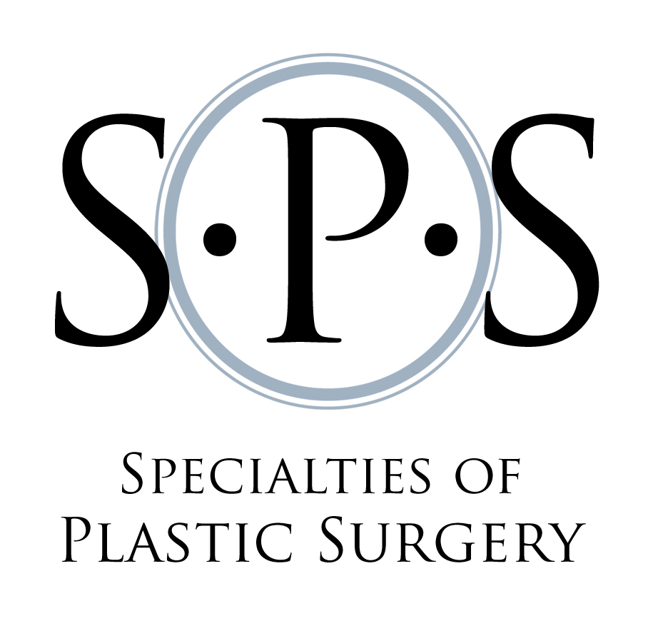
Hooman Soltanian, M.D.
Diplomate American Board of Plastic Surgery
1000 Asylum Ave
Suite 2114
Hartford, CT 06105
Office 860 . 722 . 9544
Fax 860 . 760 . 6363
www.spsct.com

AUTHORIZATION TO RELEASE MEDICAL RECORDS

I authorize Dr. Hooman Soltanian to release a copy of my complete medical records

_____________________________ _____________________________________________
Name of Patient Date of Birth

_____________________________ _____________________________________________
Social Security Number Other Identifying information if Applicable (other Names)

Transmission by facsimile or electronic means authorized to expedite transfer of records.

Release Medical Records To:

_____________________________________________________________________________________
Name

_____________________________________________________________________________________
Address

_____________________________________________________________________________________
Address

_____________________________________________________________________________________
Phone Fax

The information will be used on my behalf for the following purpose(s):

_____________________________________________________________________________________

___________________ ____________________________________________________
Date Signature of patient or Person Authorized by Law

